while loop in C

While loop is also known as a pre-tested loop. In general, a while loop allows a part of the code to be executed multiple times depending upon a given boolean condition. It can be viewed as a repeating if statement. The while loop is mostly used in the case where the number of iterations is not known in advance.

Syntax of while loop in C language

The syntax of while loop in c language is given below:

1. **while**(condition){
2. //code to be executed
3. }

Flowchart of while loop in C

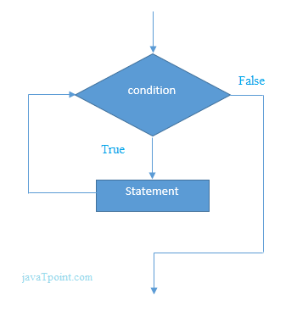

Example of the while loop in C language

Let's see the simple program of while loop that prints table of 1.

1. #include<stdio.h>
2. **int** main(){
3. **int** i=1;
4. **while**(i<=10){
5. printf("%d \n",i);
6. i++;
7. }
8. **return** 0;
9. }

Output

1

2

3

4

5

6

7

8

9

10

Program to print table for the given number using while loop in C

1. #include<stdio.h>
2. **int** main(){
3. **int** i=1,number=0,b=9;
4. printf("Enter a number: ");
5. scanf("%d",&number);
6. **while**(i<=10){
7. printf("%d \n",(number*i));
8. i++;
9. }
10. **return** 0;
11. }

Output

Enter a number: 50

50

100

150

200

250

300

350

400

450

500

Enter a number: 100

100

200

300

400

500

600

700

800

900

1000

Properties of while loop

* A conditional expression is used to check the condition. The statements defined inside the while loop will repeatedly execute until the given condition fails.
* The condition will be true if it returns 0. The condition will be false if it returns any non-zero number.
* In while loop, the condition expression is compulsory.
* Running a while loop without a body is possible.
* We can have more than one conditional expression in while loop.
* If the loop body contains only one statement, then the braces are optional.

Example 1

1. #include<stdio.h>
2. **void** main ()
3. {
4. **int** j = 1;
5. **while**(j+=2,j<=10)
6. {
7. printf("%d ",j);
8. }
9. printf("%d",j);
10. }

Output

3 5 7 9 11

Example 2

1. #include<stdio.h>
2. **void** main ()
3. {
4. **while**()
5. {
6. printf("hello Javatpoint");
7. }
8. }

Output

compile time error: while loop can't be empty

Example 3

1. #include<stdio.h>
2. **void** main ()
3. {
4. **int** x = 10, y = 2;
5. **while**(x+y-1)
6. {
7. printf("%d %d",x--,y--);
8. }
9. }

Output

infinite loop

Infinitive while loop in C

If the expression passed in while loop results in any non-zero value then the loop will run the infinite number of times.

1. **while**(1){
2. //statement
3. }